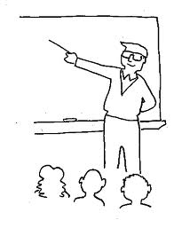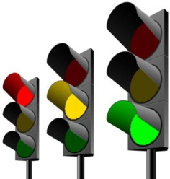

Teacher Led or Student Led?

Teacher Led or Student Led?

Teacher Led or Student Led?

Teacher Led or Student Led?

R.McGill 2012 - [@TeacherToolkit](https://twitter.com/teachertoolkit)

Learning

Episodes

The BIG picture?

***….print and scribble your way to Outstanding*!**

The 5 minute Lesson Plan

Objectives

A f L

Engagement?

Stickability!

Differentiation

**Level 4**

**Level 5**

**Level 6**

**Level 3**

**Level 7**

*along the way….*