

[www.hamidmahmood.co.uk](http://www.hamidmahmood.co.uk)

[thisishamid@gmail.com](mailto:thisishamid@gmail.com)

(SEN & G&T)

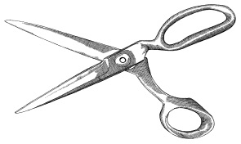

Differentiation

Individual Needs

What is the **MOST** important aspect / part of a Lesson?

**WHY?**

What is the **LEAST** important aspect / part of a Lesson?

**WHY?**

Lesson Objectives / Outcomes

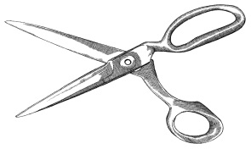

Teacher’s Lecture

Student **Progress**

Creativity

Activity at the end

of Lesson

Activity at the Start

of Lesson

Starter

Plenary

Assessment for Learning

AFL

Behaviour Management